Quantitative Elements: Amazon
Name
Institution
Course Number and Name
Instructor
Date
Quantitative Elements : Amazon
This paper will be based on Amazon Inc, a leading eCommerce company. Amazon has changed how retail is seen by using an able supply chain strategy and developing several innovative technologies. Amazon is one of the fastest-growing companies because of its constant innovation and reshaping its supply chains which do not leave any other competition in the same market. Amazon's rapid growth has been exceptional. Amazon grew approximately 20 percent per year from 2018 to 2019. Amazon makes about one trillion a year in revenue and currently earns 14 percent of gross global eCommerce sales.
Three quantitative elements separate Amazon from any other organization, which include distribution, warehousing, and technology. Amazon prime delivery is the importing component to Amazon's loyal customer base. More than half of its customers visit Amazon dot com at least three times a week, and about 83 percent of its prime customers receiving two days of shipping for free, which is the best benefit Amazon has to offer (Hahn, Kim, and Youn, 2018). In order to maintain customer loyalty Amazon, prime recently announced that they would invest $800 million to expand the availability of free one-day shipping to its prime customers. Amazon also operates a vast number of warehouses worldwide, primarily located in metropolitan areas, allowing Amazon to fill orders for customers for a reduced cost quickly.
In order to have enough capacity for particularly important items such as food, health, and personal care products during the corona crisis, Amazon restricted its FBA (Fulfillment by Amazon) service: Less important Goods were no longer accepted and processed in the warehouses. Now the online and logistics giant seems to be better prepared for the consequences of the corona crisis and is partially using the FBA service for these less important products in the United States. Online retailers who use Amazon's FBA can therefore start shipping less-needed items again. An Amazon spokesman in the United States confirmed this, and some retailers there are already reporting the changes.
Admittedly, Amazon has been a pioneer in e-commerce shipping since the beginning and has made a significant contribution to the rapid development of customer shipping requirements (Taylor, 2019). The e-commerce giant achieved this through a sophisticated network of logistics centers with a high degree of automation. This means that delivery times can be shortened, and shipping costs can be minimized due to the proximity to the end customer.
Amazon's distribution centers every day more impressed by the high technology used. The Stanislaus County, California Distribution Center (DC) is a tech logistics paradise spanning over 300,000 square meters. The structure, inaugurated over a year ago, is filled with proprietary Amazon technology, such as the incredible Kiva robots, which automate cargo movement within the warehouse.
Amazon also highly depends on its technology, such as automation solutions, to ensure that delivery is streamlined and efficient. Automation solutions is a virtual assistant that brings much value to providing human-like services and helping customers make an informed decisions regarding their purchases (Rana and Dastin, 2019). Within this technology initiative, Amazon also launched a robotic delivery system in which these delivery robots deliver packages to customers through sidewalks. Currently, this delivery service is only available to customers in southern California, but it will soon move torch the Pacific Northwest.
One Day Shipping Demand Forecast
Amazon's forecast/ demand is utilized to provide forecast information such as historical sales, promotions, and pricing. Amazon currently uses SWIGGY, a platform that predicts what may change in the key business metrics like cost per delivery, which helps in managing costs and incentives (Rana and Dastin, 2019). This platform allows the company to effectively use related data which has an impact to the business metrics to improve forecasting accuracy.
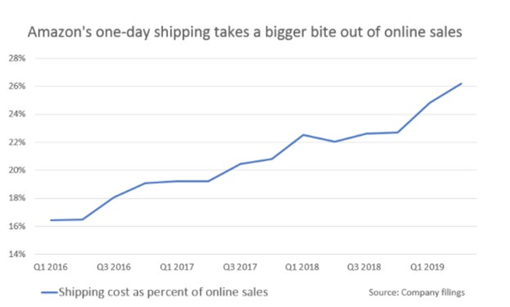
Figure 1: Trend of Shipping in Amazon
Amazon's latest earnings showed how much one-day shipping costs, but analysts suggest that Amazon benefits from these benefits. Even though some additional warehouse and inventory costs during the transition, the rewards were greater than the risk taken. Data shows that this move has been a popular item with its customers and has even generated new Amazon prime customers because of this new perk. Amazon's revenue is showing steady growth and has been profitable. Overall, Amazon expects to operate income between $2.1 billion and $3.1 Billion.
References
Hahn, Y., Kim, D., & Youn, M. K. (2018). A Brief Analysis of Amazon and Distribution Strategy. The Journal of Distribution Science, 16(4), 17-20.
Rana, A., & Dastin, J. (2019). Amazon's push for one-day delivery dents profits costs up 21% | MarketScreener. Marketscreener.com. Retrieved 14 September 2021, from https://www.marketscreener.com/quote/stock/ALPHABET-INC-24203373/news/Amazon-s-push-for-one-day-delivery-dents-profits-costs-up-21-28960023/.
Taylor, N. (2019). 3 Key Elements to Amazon’s Supply Chain Strategy. Retrieved from Feedvisor: https://feedvisor.com/resources/amazon-shipping-fba/3-key-elements-to-amazons-supplychain-strategy/

